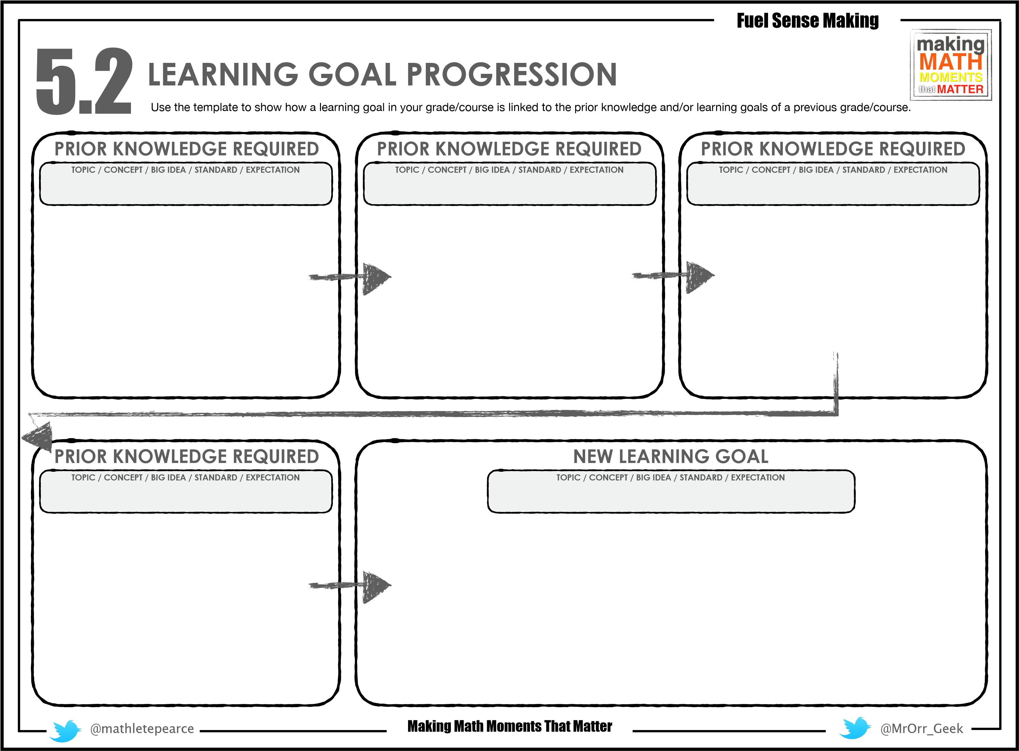

Students need to be able to take two equations, that have two unknowns and find the values of the unknowns. By now we will have done some by guess and check, we will have solved some using graphing, but now we will make both of those things difficult and work our way toward the new goal.

Need to have worked through real world examples of systems so they understand what are trying to do by substituting.

**Understanding of what a system is…**

**Plug values (substitute) into equations**

**Solve a multi-step equation**

**Use the Distributive Property**

**Solving Systems of Equations by Substitution**

Students need to be able to plug a value in for a variable and find the value of the equation

Students need to be able to isolate a variable when they start with variables on both sides of the equation

Students need to be able to leverage the distributive property in equations. They have to understand the “clear parentheses” step of solving equations.